

**DIRECT DRIVE GLIDE**

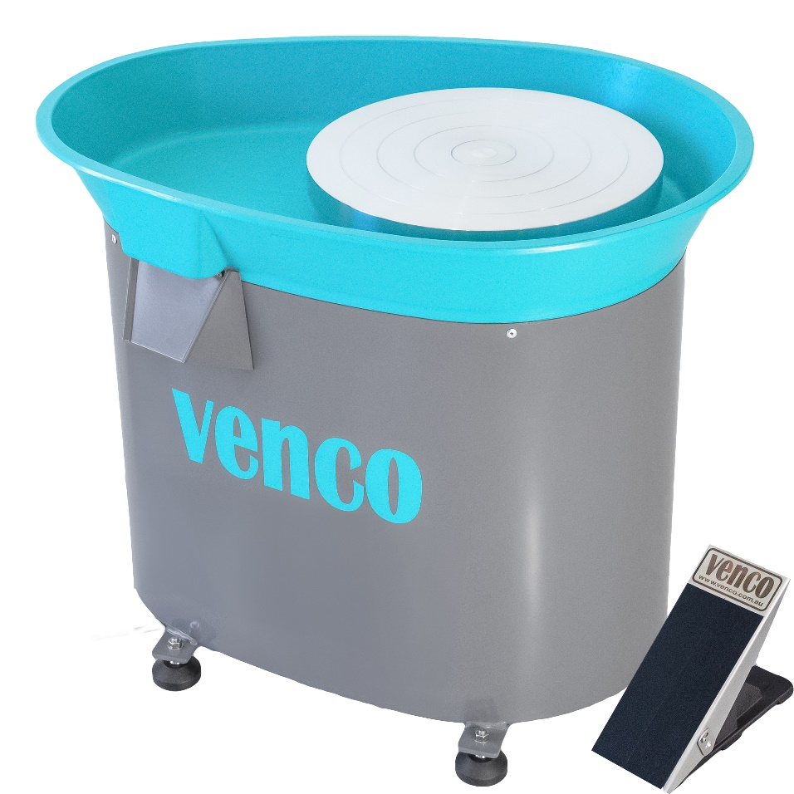

CLAYCORE PTY LTD

47 Newbey St

Milpara, WA 6330

ABN: 69 634 757 029

PLEASE READ THESE SAFETY INSTRUCTIONS CAREFULLY

** USE WITH RCD PROTECTED OUTLETS ONLY.IF YOU ARE UNSURE ASK AN ELECTRICIAN OR USE A STAND -ALONE PLUG-IN SAFETY SWITCH.**

** DO NOT OPERATE ELECTRICAL SWITCHES WITH WET HANDS.**

** ENSURE WHEEL IS SWITCHED OFF AND UNPLUGGED FROM POWER SOURCE BEFORE CLEANING OR MAINTENANCE AND AFTER OPERATION.**

** NEVER TAMPER WITH ANY OF THE ELECTRICAL COMPONENTS OF THE WHEEL AS THERE IS A RISK OF AN ELECTRIC SHOCK.**

** TO CLEAN THE WHEEL, USE A WET SPONGE. DO NOT USE A PRESSURISED WATER SOURCE IN THE VICINITY OF THE MACHINE eg. GARDEN HOSE**

** DO NOT BLOCK OFF DRAINAGE SPOUT AS THIS COULD RESULT IN WATER INGRESS TO THE MOTOR.**

** THIS WHEEL WEIGHS 40KGS. HANDLE WITH CARE WHEN MOVING OR LIFTING. IT IS RECOMMENDED THAT TWO PEOPLE HANDLE THIS WHEEL.**

** ENSURE LONG HAIR AND LOOSE CLOTHING ARE SECURED.**

** ENSURE MACHINE IS OPERATED ON A FLAT AND LEVEL SURFACE.**

** ENSURE CHILDREN ARE NOT LEFT UNATTENDED NEAR THE MACHINE.**

** ENSURE TOOLS AND ANY SMALL PARTS ARE OUT OF REACH OF CHILDREN**

** STOP OPERATION OF THE MACHINE IF SMOKE IS DETECTED OR THERE ARE UNUSUAL NOISES.**

** DO NOT INSERT HANDS OR OBJECTS INTO OPENINGS OR MOVING PARTS.**

** REPAIR OR MODIFICATION OF THE WHEEL IS PROHIBITED**

**USER CONTROLS**

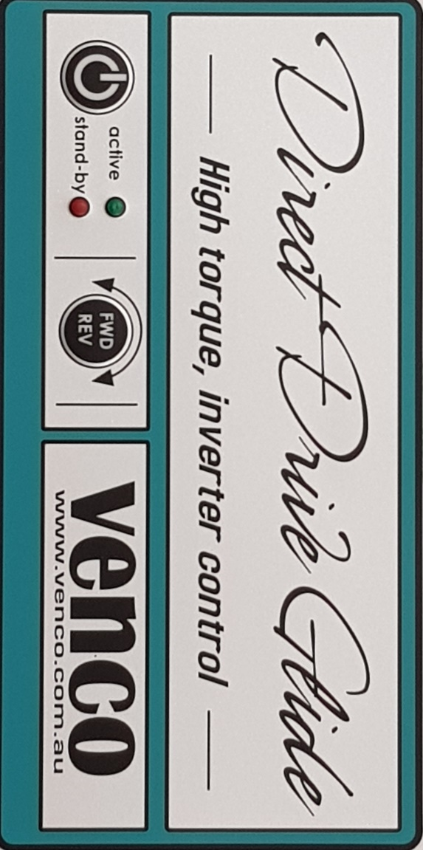

**QUICK SET UP**

**1.PLUG IN TO POWER OUTLET ONLY-DO NOT PLUG IN TO EXTENSION CORD.**

**2.ADJUST THE FOUR MAIN FEET USING SPANNER TO ENSURE LEVEL. IF THE FOOT AT THE REAR OF THE MACHINE NEEDS ADJUSTMENT, REFER TO PHOTOS BELOW.**

**3.ALWAYS WAIT FOR WHEELHEAD TO STOP ROTATINC COMPLETELY BEFORE CHANGING DIRECTION.**

`



**THANK YOU FOR PURCHASING A VENCO DIRECT DRIVE GLIDE AND SUPPORTING AUSTRALIAN MANUFACTURING.**